# **PROJECT REPORT**

# **ON**

OBJECT AND FACE DETECTION ALONG WITH ATTENDANCE SYSTEM AND HISTOGRAM EQUALIZATION IN JETSAN NAN0,ARDUNO NANO BL33SENSE



# By

M PRAVEEN KUMAR (Roll No. - 21ECB0B31)

# MVS SRIMANTH (Roll No. 21ECB0B33)

# Done Under Provisioning of

# Professor Dr J Ravi Kumar

# Electronics and Communication Engineering Department

**INDEX**

|  |  |  |
| --- | --- | --- |
| S. No. | Content | Page No. |
| 1 | ABSTRACT | 2 - 4 |
| 2 | INTRODUCTION | 4 – 10 |
| 3 | METHODOLOGY,EXPLANATION | 11 -33 |
| 4 | CODE EXPLANATION,RESULTS | 34– 43 |
| 5 | CONCLUSION,FUTURE SCOPE | 44-46 |

**ABSTRACT**

In the traditional system, it is hard to be handle the attendance of huge students in a classroom. As it is time-consuming and has a high probability of error during the process of inputting data into the computer. Real-Time Face Recognition is a real-world solution which comes with day to day activities of handling a bulk of student’s attendance. Face Recognition is a process of recognizing the students face for taking attendance by using face biometrics. In this project, a computer system will be able to find and recognize human faces fast that are being captured through a surveillance camera. Numerous algorithms and techniques have been developed for improving the performance of face recognition but our proposed system uses Haar cascade classifier to find the positive and negative of the face and LBPH (Local binary pattern histogram) algorithm for face recognition by using python programming and OpenCV library.

Contrast enhancement is an important area in the field of digital image processing for human visual perception and computer vision. The goal of contrast enhancement is to improve the quality of an image to become more suitable for a particular application. Till today, numerous image enhancement methods have been proposed for various applications and efforts have been directed to further increase the quality of the enhancement results and minimize the computational complexity and memory usage.It is extensively used for medical image processing and as a preprocessing step in speech recognition, texture synthesis, and many other image/video processing applications.

**KEYWORDS**

* Haar cascade classifier
* LBPH Algorithm
* MobileNet SSD
* Ada boost training
* Edge computing
* Depthwise seperable convolution

**INTRODUCTION**

**EDGE COMPUTING:**

Edge computing is an emerging computing paradigm which refers to a range of networks and devices at or near the user. Edge is about processing data closer to where it’s being generated, enabling processing at greater speeds and volumes, leading to greater action-led results in real time.

ATTENDANCE SYSTEM:

The technology aims in imparting tremendous knowledge oriented technical innovations these days. Machine Learning is one among the interesting domain that enables the machine to train itself by providing some datasets as input and provides an appropriate output during testing by applying different learning algorithms. Nowadays Attendance is considered as an important factor for both the student and the teacher of an educational organization. With the advancement of the Machine learning technology the machine automatically detects the attendance performance of the students and maintains a record8 of those collected data. In general, the attendance system of the student can be maintained in two, different forms namely, Manual Attendance System (MAS) Automated Attendance System (AAS). Manual Student Attendance Management system is a process where a teacher concerned with the particular subject need to call the students name and mark the attendance manually. Manual attendance may be considered as a time-consuming process or sometimes it happens for the teacher to miss someone, or students may answer multiple times on the absence of their friends. So, the problem arises when we think about the traditional process of taking attendance in the classroom. To solve all these issues, we go with Automatic Attendance System (AAS) which takes attendance in no time.

OBJECT DETECTION:

Object detection is a computer technology related to computer vision and image processing that deals with detecting instances of semantic objects of a certain class (such as humans, buildings, or cars) in digital images and videos. Well-researched domains of object detection include face detection and pedestrian detection. Object detection has applications in many areas of computer vision, including image retrieval and video surveillance.

They are extensively used in computer vision tasks like image annotations, face recognition, face detection, object tracking, and many more. Not only that but they are also used to solve real-world problems like Automated CCTV surveillance where you can keep track of some objects that may cause some threats. Objects are tracked until any threat or abnormality is found. It can then be handled by recording the footage for a certain duration and alerting the respective authorities about it.

Face recognition:

Facial recognition is a way of identifying or confirming an individual’s identity using their face. Facial recognition systems can be used to identify people in photos, videos, or in real-time.

Facial recognition is a category of biometric security. Other forms of biometric software include voice recognition, fingerprint recognition, and eye retina or iris recognition. The technology is mostly used for security and law enforcement, though there is increasing interest in other areas of use.

In the past few years, face recognition owned significant consideration and appreciated as one of the most promising applications in the field of image analysis. The method of face detection in pictures is complicated because of variability present across human faces such as pose, expression, position and orientation, skin colour, the presence of glasses or facial hair, differences in camera gain, lighting conditions, and image resolution.

Image enhancement is one of the most important researches in image processing . Because of noise, light and other environmental factors, or the reasons of the electronic device itself, usually, the quality of the original digital image is not very high, so, before the operation of the image edge detection or image segmentation, improving the visual appearance of the original digital image is necessary.

Histogram equalization is a nonlinear extension of the image, redistribution of the image pixels' values, and within a certain grayscale range, the number of pixels is almost the same. Histogram can also be used on color images by applying the same method separately to the Red, Green and Blue components of the RGB color values of the image.

**LIBRARIES USED:**

##  Image and Object Recognition:

1. Open cv2-version 4.6.0-for model and image capture
2. Pytorch - to access gpu in jetsan nano
3. numpy
4. TensorFlow
5. os python

* Attendance monitoring system:

1. Pytorch
2. Time
3. Glob
4. Imutils
5. Pil
6. Open-cv2
7. Tqdm.notebook

# **ABOUT JETSEN NANO**

* NVIDIA Jetson Nano Developer Kit is a small, powerful computer that lets run multiple neural networks in parallel for applications like image classification, object detection, segmentation, and speech processing. All in an easy-to-use platform that runs in as little as 5 watts.
  + It’s simpler than ever to get started! Just inserting a microSD card with the system image, booting the developer kit, and beginning with the same NVIDIA Jetpack SDK which is used across the entire NVIDIA Jetson family of products which makes it easy to access a great small sized computer.
* Jetpack is compatible with NVIDIA’s world-leading AI platform for training and deploying AI software, reducing complexity and effort for developers.
* However, to make use of the total processing power of the nano there are lot of things to setup for this current application. It is compatible with rasp-camera V2 which will be used in this application 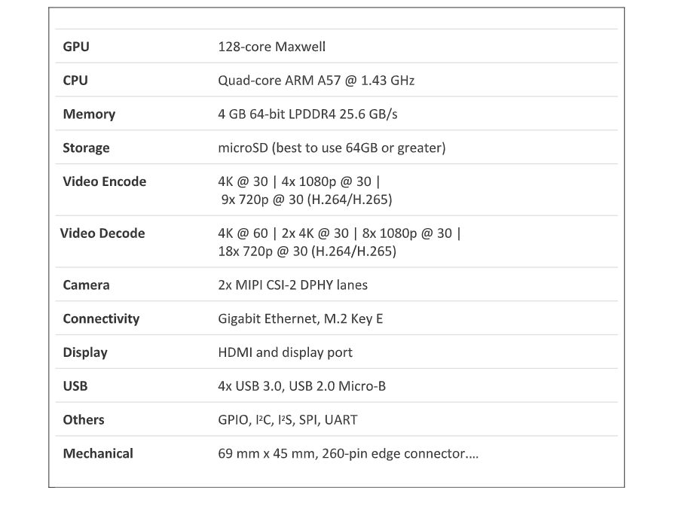

NVIDIA Jetson products provides a SD card image for the complete OS setup of the Jetson-nano that includes Ubuntu 18.04. There is much more customized setup to be done in order to deploy our AI or ML application.

### **OPEN CV**

Computer vision is a process by which we can understand the images and videos how they are stored and how we can manipulate and retrieve data from them. Computer Vision is the base or mostly used for Artificial Intelligence. Computer-Vision is playing a major role in self-driving cars, robotics as well as in photo correction apps.

OpenCV is the huge open-source library for the computer vision, machine learning, and image processing and now it plays a major role in real-time operation which is very important in today’s systems. By using it, one can process images and videos to identify objects, faces, or even handwriting of a human. When it integrated with various libraries, such as NumPy, python is capable of processing the OpenCV array structure for analysis. To Identify image pattern and its various features we use vector space and perform mathematical operations on these features.

#### COCO DATASET:

COCO stands for Common Objects in Context, as the image dataset was created with the goal of advancing [image recognition](https://viso.ai/computer-vision/image-recognition/). The COCO dataset contains challenging, high-quality visual datasets for computer vision, mostly state-of-the-art neural networks.

**Features of the COCO dataset:**

•Object segmentation with detailed instance annotations

•Recognition in context

•Superpixel stuff segmentation

•Over 200’000 images of the total 330’000 images are labeled

•1.5 Mio object instances

•80 object categories, the “COCO classes”, which include “things” for which individual instances may be easily labeled (person, car, chair, etc.)

* Object segmentation with detailed instance annotations
* Recognition in context
* Superpixel stuff segmentation

•80 object categories, the “COCO classes”, which include “things” for which individual instances may be easily labeled (person, car, chair, MORE THAN 320000 images are present in the data set and microsoft designed this data set.

**PIL library**:

Opening, rotating and displaying an image

To load the image, we simply import the image module from the pillow and call the **Image.open()**, passing the image filename.

Instead of calling the Pillow module, we will call the PIL module as to make it backward compatible with an older module called Python Imaging Library (PIL). That’s why our code starts with **“from PIL import Image”** instead of **“from Pillow import Image”**.

Next, we’re going to load the image by calling the **Image.open() function**, which returns a value of the Image object data type. Any modification we make to the image object can be saved to an image file with the **save()** method. The image object we received using **Image.open()**, later can be used to resize, crop, draw or other image manipulation method calls on this Image object.

**OS library:**

The OS module in Python provides functions for interacting with the operating system. OS comes under Python’s standard utility modules. This module provides a portable way of using operating system-dependent functionality. The *os* and *os.path* modules include many functions to interact with the file system.

PYTORCH:

PyTorch is a machine learning framework based on the Torch library, used for applications such as computer vision and natural language processing, originally developed by Meta AI and now part of the Linux Foundation umbrella. It is free and open-source software released under the modified BSD license.Used for cuda programming.

What is NumPy?

NumPy is a Python library used for working with arrays. It also has functions for working in domain of linear algebra, fourier transform, and matrices.

NumPy was created in 2005 by Travis Oliphant. It is an open source project and you can use it freely. NumPy stands for Numerical Python.

Why Use NumPy?

1. In Python we have lists that serve the purpose of arrays, but they are slow to process.
2. NumPy aims to provide an array object that is up to 50x faster than traditional Python lists.
3. The array object in NumPy is called ndarray, it provides a lot of supporting functions that make working with ndarray very easy.

#### METHODOLOGY:

#### Object Detection

Object detection is a computer technology related to computer vision and image processing that deals with detecting instances of semantic objects of a certain class (such as humans, buildings, or cars) in digital images and videos. Well-researched domains of object detection include face detection and pedestrian detection. Object detection has applications in many areas of computer vision, including image retrieval and video surveillance.

They are extensively used in computer vision tasks like image annotations, face recognition, face detection, object tracking, and many more. Not only that but they are also used to solve real-world problems like Automated CCTV surveillance where you can keep track of some objects that may cause some threats. Objects are tracked until any threat or abnormality is found. It can then be handled by recording the footage for a certain duration and alerting the respective authorities about it.

FLOW CHART:

How does object detection work?

Object detection works in a similar way as object recognition. The only difference is that object recognition is the process of identifying the correct object category whereas object detection simply detects the object's presence and location in an image.

Object detection tasks can be performed by two different methods of data analysis techniques. They are:

1. Image processing is a part of unsupervised learning that doesn't require historical training data to teach analytics models. The models self-train themselves on the input images and create feature maps to make predictions. Image processing does not require high graphical processing power (GPU) or large datasets for execution.
2. Deep neural network: A deep neural network is generally a supervised learning algorithm that requires large datasets and high GPU computation power to predict object classes. It’s a more accurate way to classify objects which are partially hidden, complex, or placed in unknown backgrounds in an image.

#### **MOBILE NET**

As the name applied, the MobileNet model is designed to be used in mobile applications, and it is TensorFlow’s first mobile computer vision model.

MobileNet uses depth wise separable convolutions. It significantly reduces the number of parameters when compared to the network with regular convolutions with the same depth in the nets. This results in lightweight deep neural networks.

A depth wise separable convolution is made from two operations.

1. Pointwise convolution.
2. Depthwise convolution

MobileNet is a class of CNN that was opensourced by Google, and therefore, this gives us an excellent starting point for training our classifiers that are insanely small and insanely fast. 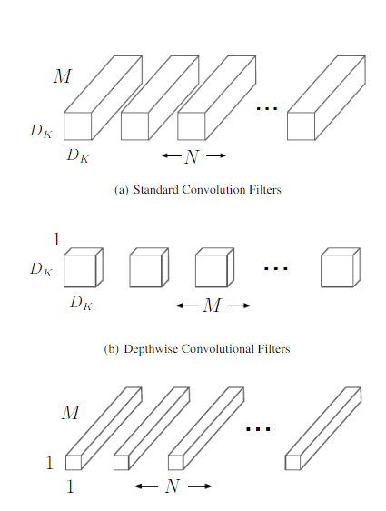

MobileNets are a family of mobile-first computer vision models for TensorFlow, designed to effectively maximize accuracy while being mindful of the restricted resources for an on-device or embedded application.

MobileNets are small, low-latency, low-power models parameterized to meet the resource constraints of a variety of use cases. They can be built upon for classification, detection, embeddings, and segmentation.

As it uses the idea of Depth convolution and point convolution which is different from the normal convolution as done by normal CNNs. This increases the efficiency of CNN to predict images and hence they can be able to compete in the mobile systems as well. Since these ways of convolution reduce the comparison and recognition time a lot, so it provides a better response in a very short time and hence we are using them as our image recognition model.

**CALCULATIONS FOR MOBILET:**

# **1. Depthwise Separable Convolution**

**Depthwise separable convolution is a depthwise convolution followed by a pointwise convolution as follows :**

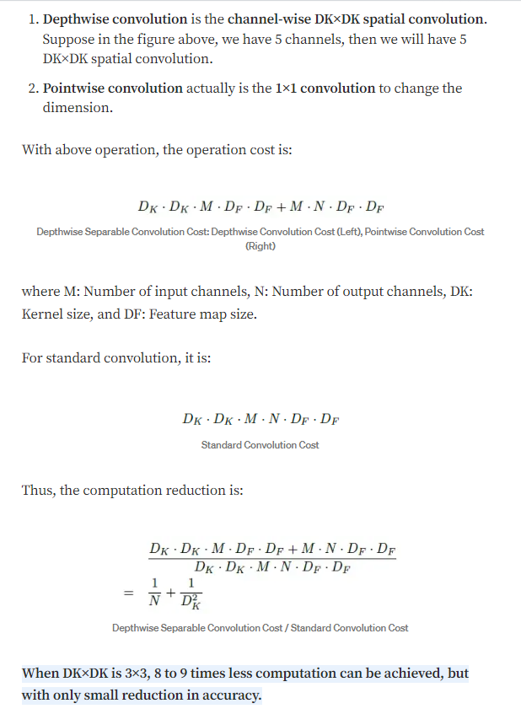

**SSD (single shot detector):**

The term SSD stands for Single Shot Detector. The SSD technique is based on a forward convolutional network that generates a collection of fixed-size bounding boxes and a score for the presence of object class instances in those boxes, which come behind by a non-maximal suppression step to create the final detections. Fields contain offset values (cx,cy,w,h) from the default field. The score contains confidence values for the presence of each of the object categories, with a value of 0 reserved for the background.

SSD represents multi-reference and multi-resolution detection techniques. Multi-reference techniques define a set of anchor boxes of different sizes and aspect ratios at different locations in the image and then predict a detection box based on these references. Multi-resolution techniques enable object detection at multiple scales and at different network layers. The SSD network implements an algorithm for detecting multiple object classes in images by generating a confidence score related to the presence of any object category in each default field. It also makes adjustments in the boxes to better fit the shapes of the objects. This network is suitable for real-time applications because it does not resample functions for bounding box hypotheses.

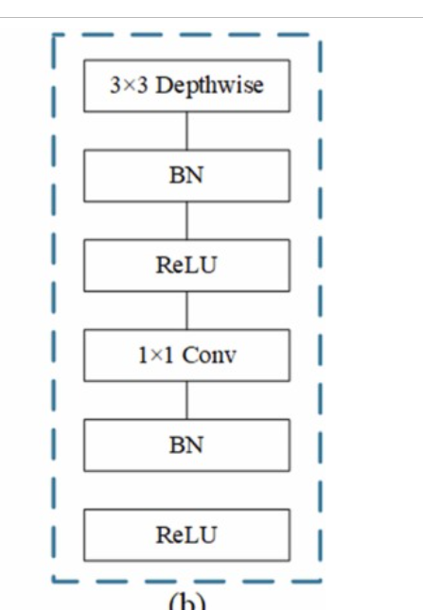 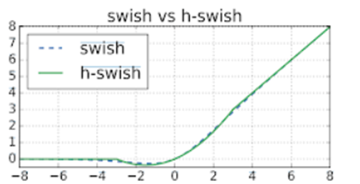

**MOBILE NET SSD:**

Convolutional neural networks are used to develop a model that consists of multiple layers for classifying given objects into one of the defined classes. These objects are detected using higher resolution feature maps made possible by recent advances in deep learning with image processing. Mobilenet SSD is an object detection model that computes the output bounding box and object class from the input image. This Single Shot Detector (SSD) object detection model uses Mobilenet as a backbone and can achieve fast object detection optimized for mobile devices.

**Significance of Frozen inference graph**

Freezing is the process to identify and save all of required things(graph, weights etc) in a single file that you can easily use. Frozen graphs are commonly used for inference in TensorFlow .

**What does .zip() and .flatten() do?**

It makes a set/list from the values taken by its arguments. The purpose of Python zip() method is to map the similar index of multiple containers so that they can be used just using as single entity.  
Flattening lists in python means converting multidimensional lists into one-dimensional lists. It is basically a method of merging all the sublists of a nested list into one unified list.

##### **What does the dnn_DetectionModel() do**

It is a deep neural network model that helps in loading a pretrained model, (ssdmobilenet in our case). The DNN module allows loading pre-trained models of most popular deep learning frameworks, including Tensorflow, Caffe, Darknet, Torch.

##### **BBOX:**

You may think it has a error in its spelling , but it didn’t . The b in bbox is for bounding. Bounding boxes can be useful as standalone shapes, but they are primarily used for approximating more complex shapes to speed operations. It is intended to ease the use of 2D and 3D bounding boxes in areas such as Object Detection by providing a set of flexible primitives and functions that are intuitive and easy to use out of the box.

**NON MAX SUPPRESSION:**

Non-max suppression is the final step of these object detection algorithms and is used to select the most appropriate bounding box for the object. In this article, I will introduce the concept of non-max suppression, why it is used, and explain how it works in the object detection algorithms.

We are able to achieve 20fps on jetsan nano.

H-swish activation:

The function **allows data normalization and leads to quicker convergence and learning of the neural network**.

##### **FACE RECOGNITION:**

Facial recognition is a way of identifying or confirming an individual’s identity using their face. Facial recognition systems can be used to identify people in photos, videos, or in real-time.

Facial recognition is a category of biometric security. Other forms of biometric software include voice recognition, fingerprint recognition, and eye retina or iris recognition. The technology is mostly used for security and law enforcement, though there is increasing interest in other areas of use.

In the past few years, face recognition owned significant consideration and appreciated as one of the most promising applications in the field of image analysis. The method of face detection in pictures is complicated because of variability present across human faces such as pose, expression, position and orientation, skin color, the presence of glasses or facial hair, differences in camera gain, lighting conditions, and image resolution.

WORK FLOW:

##### **HAAR CASCADE CLASSIFIER**

It is an Object Detection Algorithm used to identify faces in an image or a real time video. The algorithm uses edge or line detection features proposed by Viola and Jones in their research paper “Rapid Object Detection using a Boosted Cascade of Simple Features” published in 2001. The algorithm is given a lot of positive images consisting of faces, and a lot of negative images not consisting of any face to train on them.

It works in four stages:

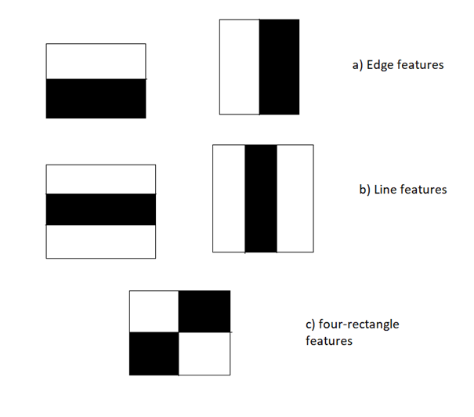

• **Haar-feature selection:** A Haar-like feature consists of dark regions and light regions. It produces a single value by taking the difference of the sum of the intensities of the dark regions and the sum of the intensities of light regions. It is done to extract useful elements necessary for identifying an object. The features proposed by viola and jones are:

•**Creation of Integral Images**: A given pixel in the integral image is the sum of all the pixels on the left and all the pixels above it. Since the process of extracting Haar-like features involves calculating the difference of dark and light rectangular regions, the introduction of Integral Images reduces the time needed to complete this task significantly.

•**AdaBoost Training**: This algorithm selects the best features from all features. It combines multiple “weak classifiers” (best features) into one “strong classifier”. The generated “strong classifier” is basically the linear combination of all “weak classifiers”.

•**Cascade Classifier**: It is a method for combining increasingly more complex classifiers like AdaBoost in a cascade which allows negative input (non-face) to be quickly discarded while spending more computation on promising or positive face-like regions. It significantly reduces the computation time and makes the process more efficient.

OpenCV comes with lots of pre-trained classifiers. Those XML files can be loaded by cascade Classifier method of the cv2 module. Here we are going to use haarcascade_frontalface_default.xml for detecting faces

ATTENDANCE SYSTEM:

In many of the educational institutions, managing attendance of students/candidates is tedious, as there would be large number of students in the class and keeping track of all is onerous. There are situations where student act as proxies for their friends even though they are not present. This system, which is based on face detection and recognition algorithms, spontaneously detects the student when he enters the class room and marks the attendance by recognizing him. The database is then modified or updated automatically. This reduces time and effort of manually updating the attendance. This system also provides authentication using recognition of face of the admin or teacher to unlock as there are chances of trespassing by the third party. So this rises the security of the system and it save the time .

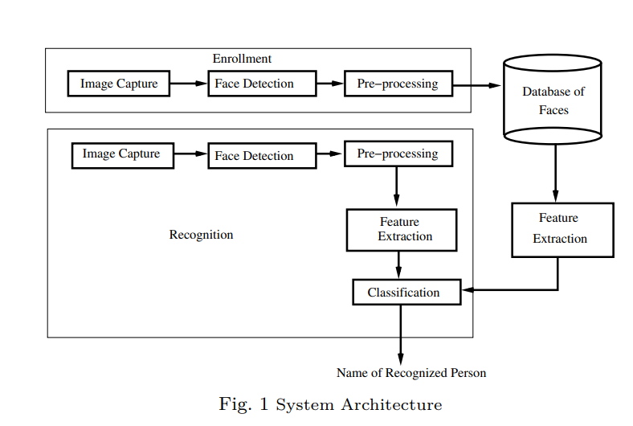

WORKFLOW:

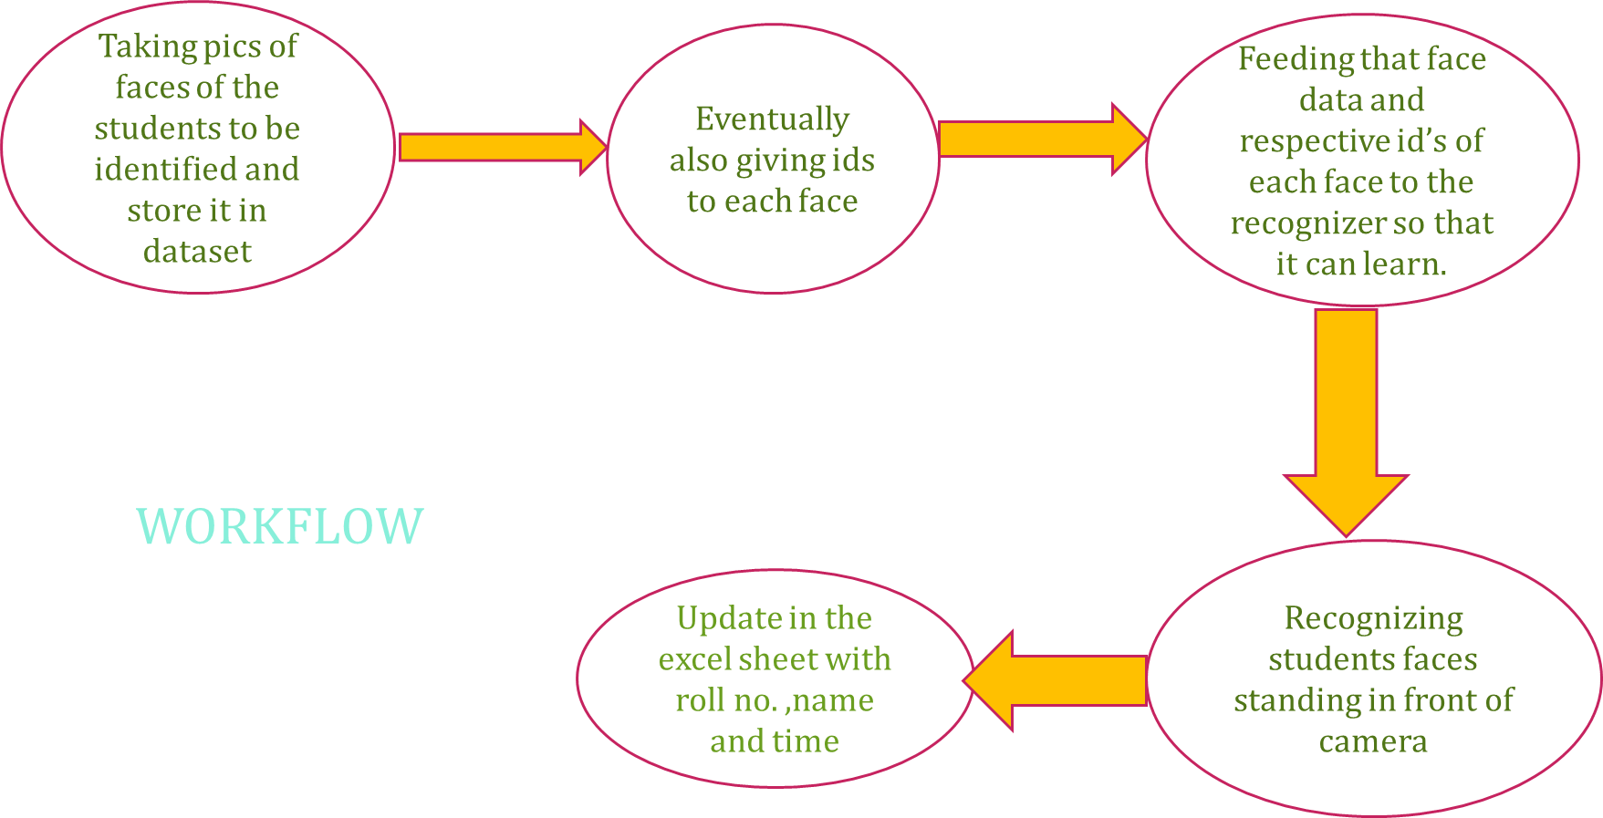

We used **Detect multiscale** function to find faces or eyes. There is a brief explanation of the function below:

**DETECT MULTISCALE**

It Finds rectangular regions in the given image that are likely to contain objects the cascade has been trained for and returns those regions as a sequence of rectangles. The function scans the image several times at different scales. Each time it considers overlapping regions in the image. It may also apply some heuristics to reduce number of analyzed regions, such as Canny prunning. After it has proceeded and collected the candidate rectangles (regions that passed the classifier cascade), it groups them and returns a sequence of average rectangles for each large enough group.

Function is:

cv2.CascadeClassifier.detectMultiScale( image, scaleFactor, minNeighbors, flags, minSize , maxSize )

Where the parameters are:

* **Image** : Containing an image where objects are detected.
* **Scalefactor** : Parameter specifying how much the image size is reduced at each image scale.

Since the classifier model was trained with the fixed face size images which can be seen in the xml file. It can detect faces with the same size which was used during the training. So what if our input image has faces smaller or bigger than what was used then. Now, for this reason, we want our image in different scales so that the model can detect a face.

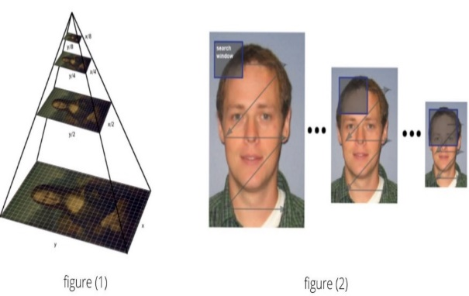

Scale factor =1.05 Means we reduce the image size by 5% each time we scale. This would generate more number of layers since the image is downsized each time by only 5%. With this large number of layers, the algorithm works slower. And since it is more precise the algorithm would take some non-face areas into consideration.

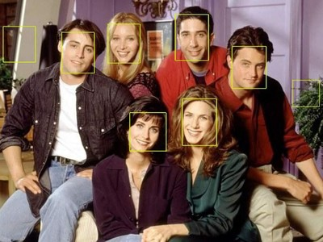

Scale factor =1.8 This large value would generate less number of layers and accordingly the algorithm works faster and can miss some faces.

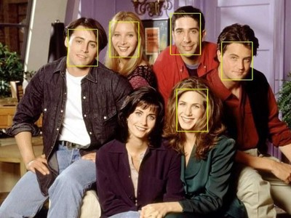

Scale factor = 1.3 is the value which we take into consideration giving the output as

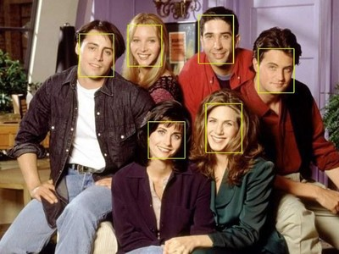

* **Minneighbors** : Parameter specifying how many neighbors each candidate rectangle should have to retain it. This parameter will affect the quality of the detected faces: higher value results in less detections but with higher quality. We're using 5 in the code.

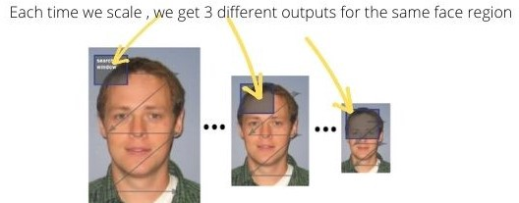

Since the object detection works in the combination of the *image pyramid (multi-scaling)*and *sliding window,*we get **multiple** true outputs for a single region of the face. These true outputs are the window region which satisfies the Haar features (could be actual face area or a non-face area taken into consideration).

Therefore, to get an actual face rectangle, the number of rectangles for the same face region must be higher than the *minNeighbors*.

minNeighbor = 0. In the figure below some areas have multiple true outputs.

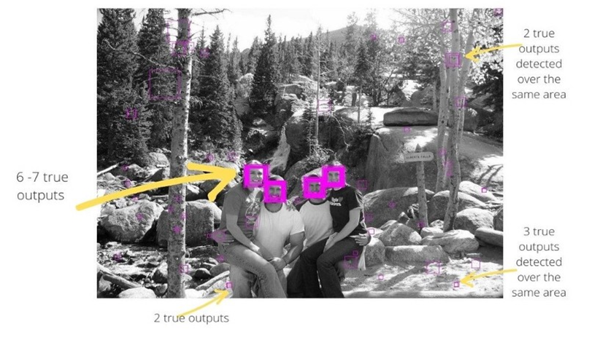

Setting minNeighbor = 3, the area with less than 3 true outputs will not get detected by the classifier. It also includes non faces too.Since minNeighbor is the threshold value for the number of true outputs required to detect a face.

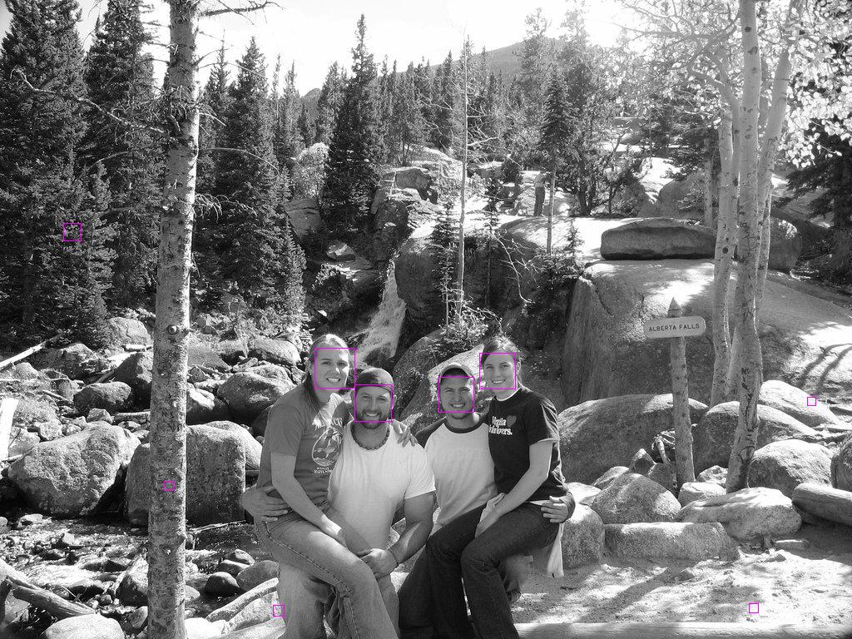

Setting minNeighbor = 5, the area with less than 5 true outputs will not get detected by the classifier. Since minNeighbor is the threshold value for the number of true outputs required to detect a face.

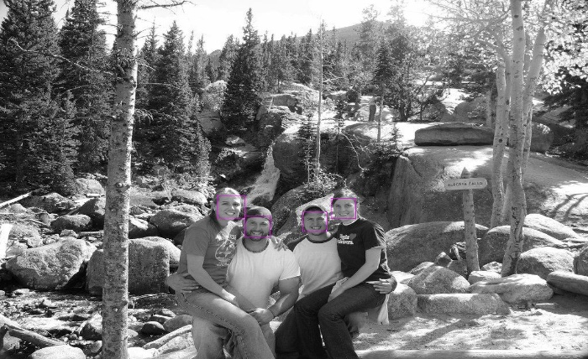

* **MinSize :** Minimum possible object size. Objects smaller than that are ignored.
* **MaxSize**: Maximum possible object size. Objects larger than that are ignored.

**HISTOGRAM**

Histogram is a graphical representation of the intensity distribution of an image. In simple terms, it represents the number of pixels for each intensity value considered.

In the figure, X-axis represents the total scale (black at the left and white at the right), and Y-axis represents the number of pixels in an image. Here, the histogram shows the number of pixels for each brightness level (from black to white), and when there are more pixels, the peak at the certain brightness level is higher .

**USES:**

* To Remove noise from the images
* It is used to analyze an image. Properties of an image can be predicted by the detailed study of the histogram.
* It is used for image equalization. Gray level intensities are expanded along the x-axis to produce a high contrast image.
* Image processing
* The brightness of the image can be adjusted by having the details of its histogram.

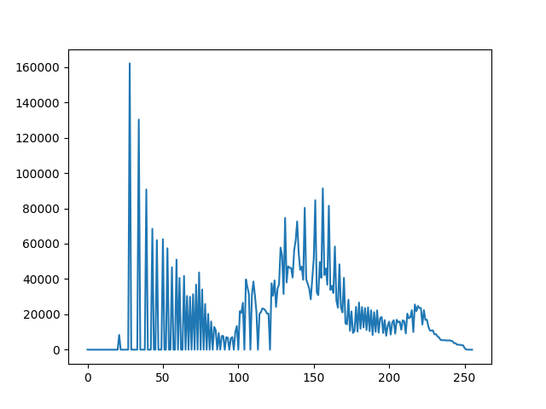

**We used histograms to detect faces of each student which is discussed below:**

**LBPH(LOCAL BINARY PATTERNS HISTOGRAMS) ALGORITHM**

***Local Binary Pattern****(LBP) is a simple yet very efficient texture operator which labels the pixels of an image by thresholding the neighborhood of each pixel and considers the result as a binary number.*

It was first described in 1994 (LBP) and has since been found to be a powerful feature for texture classification. It has further been determined that when LBP is combined with histograms of oriented gradients (HOG) descriptor, it improves the detection performance considerably on some datasets.

Using the LBP combined with histograms we can represent the face images with a simple data vector.

As LBP is a visual descriptor it can also be used for face recognition tasks, as can be seen in the following step-by-step explanation.

**Step-by-Step**

Now that we know a little more about face recognition and the LBPH, let’s go further and see the steps of the algorithm:

1. **Parameters**: the LBPH uses 4 parameters:

* **Radius**: the radius is used to build the circular local binary pattern and represents the radius around the central pixel. It is usually set to 1.
* **Neighbors**: the number of sample points to build the circular local binary pattern. Keep in mind: the more sample points you include, the higher the computational cost. It is usually set to 8.
* **Grid X**: the number of cells in the horizontal direction. The more cells, the finer the grid, the higher the dimensionality of the resulting feature vector. It is usually set to 8.
* **Grid Y**: the number of cells in the vertical direction. The more cells, the finer the grid, the higher the dimensionality of the resulting feature vector. It is usually set to 8.

**2.** **Training the Algorithm**: First, we need to train the algorithm. To do so, we need to use a dataset with the facial images of the people we want to recognize. We need to also set an ID (it may be a number or the name of the person) for each image, so the algorithm will use this information to recognize an input image and give you an output. Images of the same person must have the same ID. With the training set already constructed, let’s see the LBPH computational steps.

**3. Applying the LBP operation**: The first computational step of the LBPH is to create an intermediate image that describes the original image in a better way, by highlighting the facial characteristics. To do so, the algorithm uses a concept of a sliding window, based on the parameters **radius** and **neighbors**.

The image below shows this procedure:

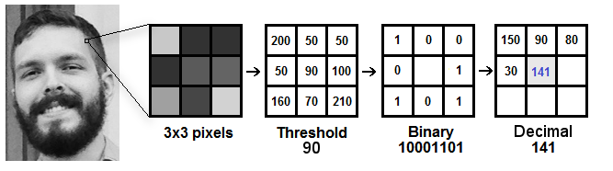

Based on the image above, let’s break it into several small steps so we can understand it easily:

* Suppose we have a facial image in grayscale.
* We can get part of this image as a window of 3x3 pixels.
* It can also be represented as a 3x3 matrix containing the intensity of each pixel (0~255).
* Then, we need to take the central value of the matrix to be used as the threshold.
* This value will be used to define the new values from the 8 neighbors.
* For each neighbor of the central value (threshold), we set a new binary value. We set 1 for values equal or higher than the threshold and 0 for values lower than the threshold.
* Now, the matrix will contain only binary values (ignoring the central value). We need to concatenate each binary value from each position from the matrix line by line into a new binary value (e.g. 10001101). Note: some authors use other approaches to concatenate the binary values (e.g. clockwise direction), but the final result will be the same.
* Then, we convert this binary value to a decimal value and set it to the central value of the matrix, which is actually a pixel from the original image.
* At the end of this procedure (LBP procedure), we have a new image which represents better the characteristics of the original image.
* **Note**: The LBP procedure was expanded to use a different number of radius and neighbors, it is called Circular LBP.

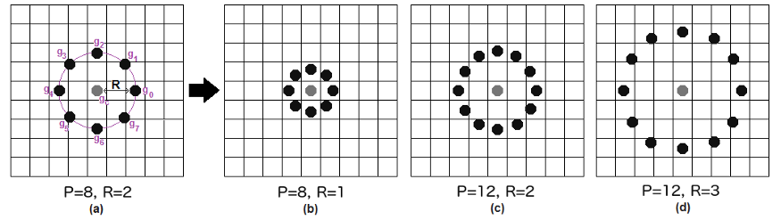

It can be done by using **bilinear interpolation**. If some data point is between the pixels, it uses the values from the 4 nearest pixels (2x2) to estimate the value of the new data point.

**4. Extracting the Histograms**: Now, using the image generated in the last step, we can use the **Grid X** and **Grid Y** parameters to divide the image into multiple grids, as can be seen in the following image:

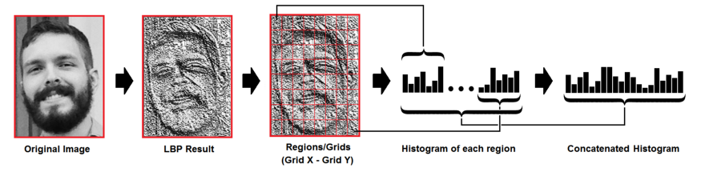

Based on the image above, we can extract the histogram of each region as follows:

* As we have an image in grayscale, each histogram (from each grid) will contain only 256 positions (0~255) representing the occurrences of each pixel intensity.
* Then, we need to concatenate each histogram to create a new and bigger histogram. Supposing we have 8x8 grids, we will have 8x8x256=16.384 positions in the final histogram. The final histogram represents the characteristics of the image original image.

The LBPH algorithm is pretty much it.

**5. Performing the face recognition**: In this step, the algorithm is already trained. Each histogram created is used to represent each image from the training dataset. So, given an input image, we perform the steps again for this new image and creates a histogram which represents the image.

* So to find the image that matches the input image we just need to compare two histograms and return the image with the closest histogram.
* We can use various approaches to compare the histograms (calculate the distance between two histograms), for example: **euclidean distance**, **chi-square**, **absolute value**, etc. In this example, we can use the Euclidean distance (which is quite known) based on the following formula:

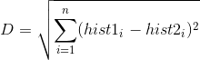

* So the algorithm output is the ID from the image with the closest histogram. The algorithm should also return the calculated distance, which can be used as a ‘**confidence**’ measurement. **Note**: don’t be fooled about the ‘confidence’ name, as lower confidences are better because it means the distance between the two histograms is closer.
* We can then use a threshold and the ‘confidence’ to automatically estimate if the algorithm has correctly recognized the image. We can assume that the algorithm has successfully recognized if the confidence is lower than the threshold defined.

**USES**

* LBPH is one of the easiest face recognition algorithms.
* It can represent local features in the images.
* It is possible to get great results (mainly in a controlled environment).
* It is robust against monotonic gray scale transformations.
* It is provided by the opencv library (Open Source Computer Vision Library).

**TINY ML**

When you say “Alexa” or “Ok, Google”, you want your devices to respond to you instantly. Waiting for the device to send your voice to the servers where it is processed, and the information is retrieved. This takes time and cripples the user experience. Again, in this case, you want the machine learning model to run locally.

Edge computing is a distributed computing paradigm that brings computation and data storage closer to the sources of data. This is expected to improve response times and save bandwidth. It is an architecture rather than a specific technology. It is a topology- and location-sensitive form of distributed computing.

TinyML is a field of study in Machine Learning and Embedded Systems that explores the types of models you can run on small, low-powered devices like microcontrollers. It enables low-latency, low power and low bandwidth model inference at edge devices. While a standard consumer CPUs consume between 65 watts and 85 watts and standard consumer GPU consumes anywhere between 200 watts to 500 watts, a typical microcontroller consumes power in the order of milliwatts or microwatts. That is around a thousand times less power consumption. This low power consumption enables the TinyML devices to run unplugged on batteries for weeks, months, and in some cases, even years, while running ML applications on edge.

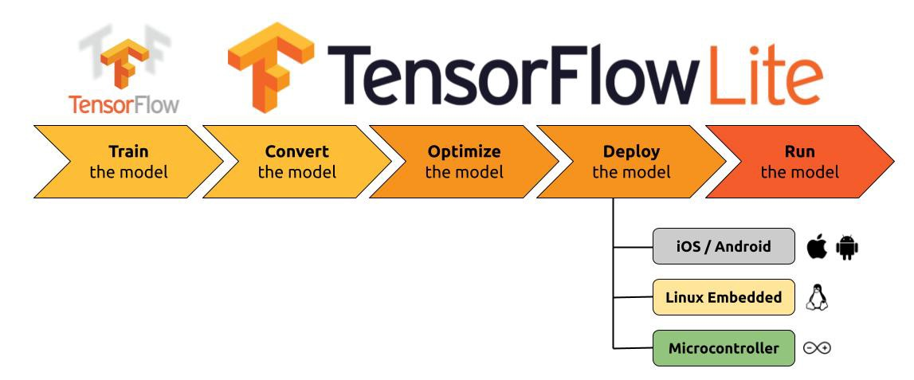

**Advantages of TinyML**

* **Low Latency:** Since the model runs on the edge, the data doesn't have to be sent to a server to run inference. This reduces the latency of the output.
* **Low Power Consumption**: As we discussed before, microcontrollers consume very little power. This enables them to run without being charged for a really long time.
* **Low Bandwidth**: As the data doesn’t have to be sent to the server constantly, less internet bandwidth is used.
* **Privacy**: Since the model is running on the edge, your data is not stored in any servers.

**ARDUINO NANO 33 BLE SENSE**

The Arduino Nano 33 BLE Sense combines a tiny form factor, different environment sensors and the possibility to run AI using TinyML and TensorFlow™ Lite. Whether you are looking at creating your Bluetooth® Low Energy to connect your project to your phone, the Nano 33 Birst embedded ML application or you want to use LE Sense will make that journey easy.

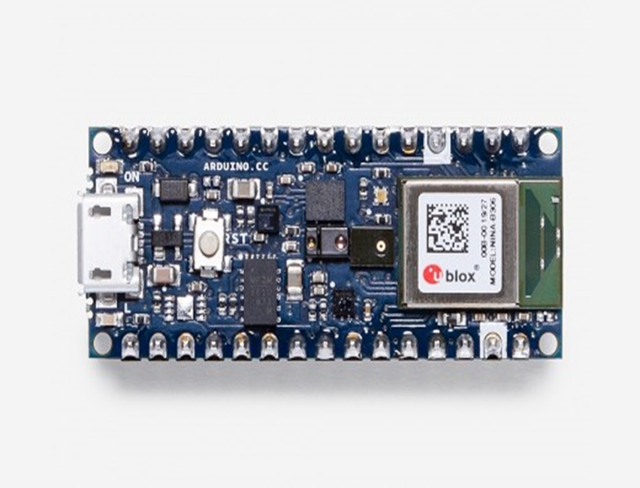

* The Arduino Nano 33 BLE is an evolution of the traditional Arduino Nano, but featuring a lot more powerful processor, the nRF52840 from Nordic Semiconductors, a 32-bit ARM® Cortex®-M4 CPU running at 64 MHz. This will allow you to make larger programs than with the Arduino Uno (it has 1MB of program memory, 32 times bigger), and with a lot more variables (the RAM is 128 times bigger). The main processor includes other amazing features like Bluetooth® pairing via NFC and ultra low power consumption modes.
* The Nano 33 BLE comes with a 9 axis inertial measurement unit (IMU) which means that it includes an accelerometer, a gyroscope, and a magnetometer with 3-axis resolution each. This makes the Nano 33 BLE the perfect choice for more advanced robotics experiments, exercise trackers, digital compasses, etc.
* Below image shows the sensors which are present in Arduino :

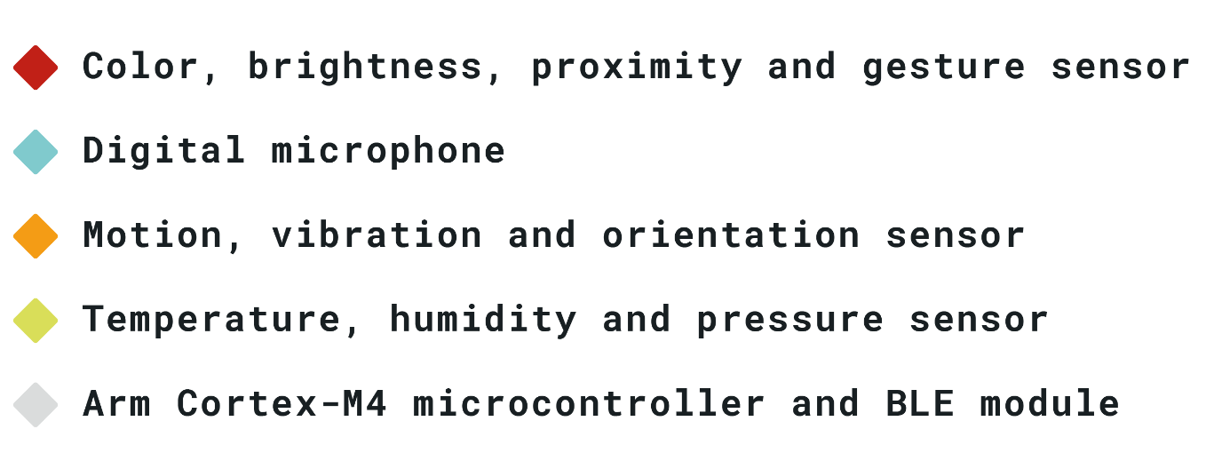

**Architecture:**

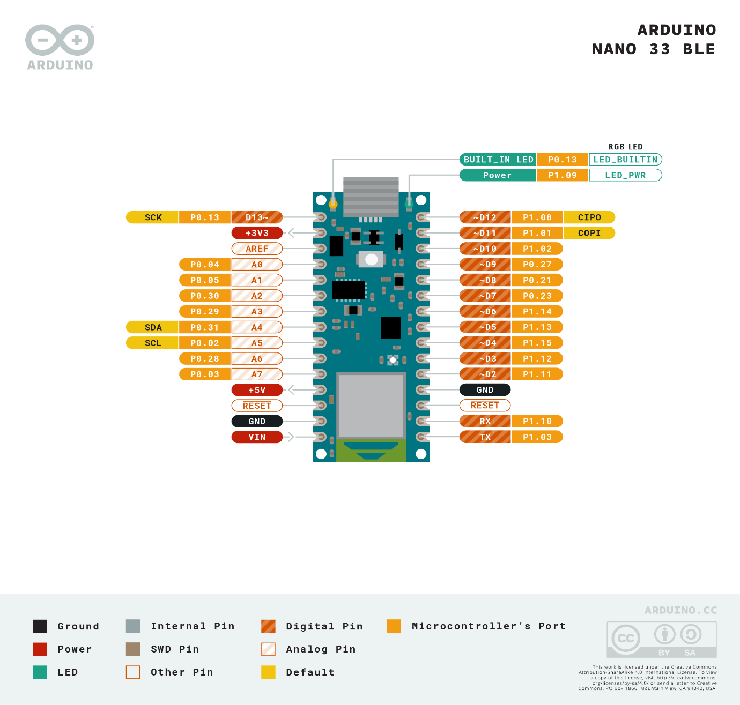

**Specifications:**

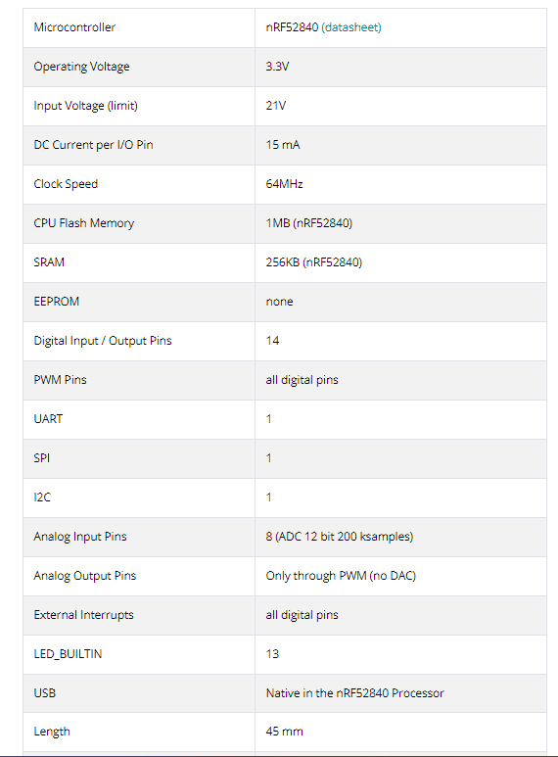

**WORKFLOW:**

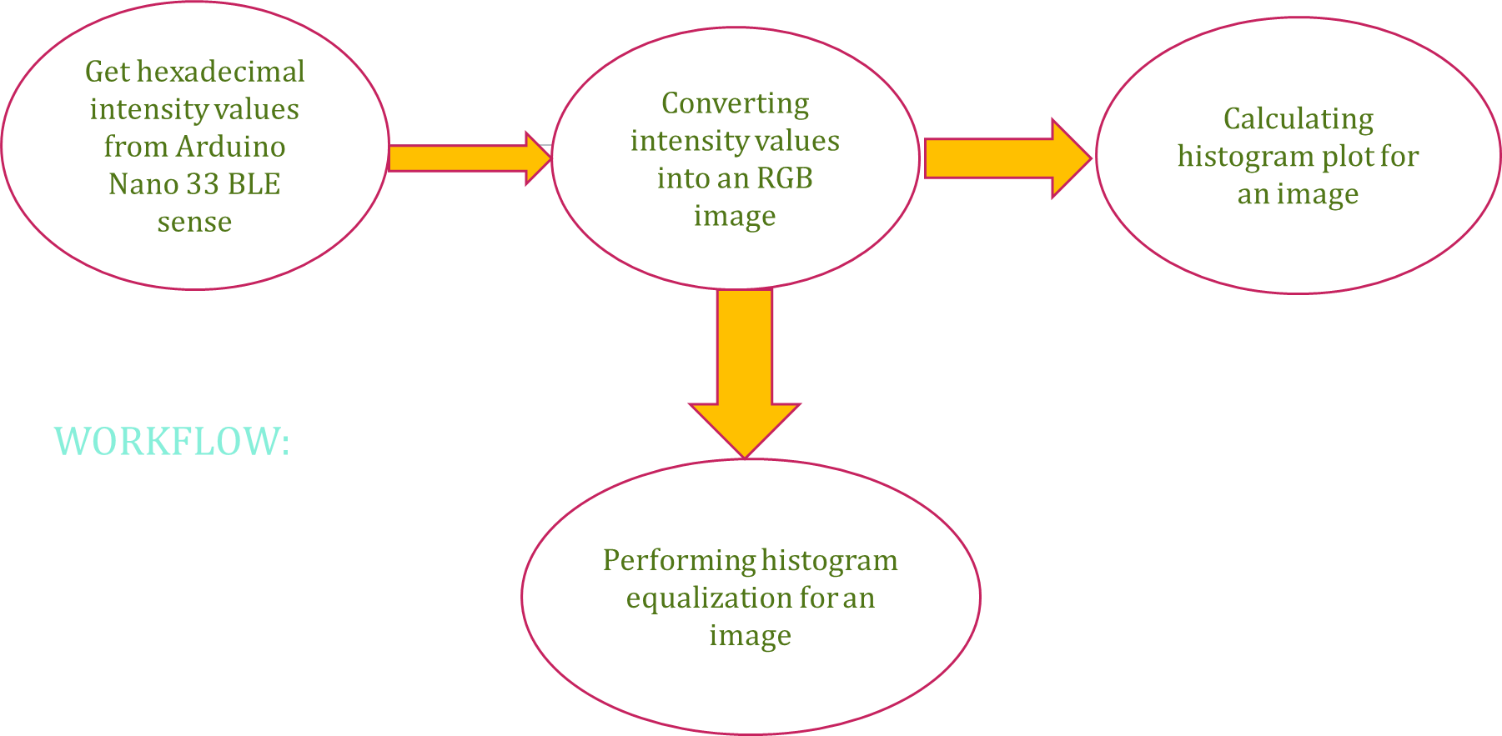

**Histogram equalization**

Histogram Equalization is a computer image processing technique used to improve contrast in images. It accomplishes this by effectively spreading out the most frequent intensity values, i.e. stretching out the intensity range of the image. This method usually increases the global contrast of images when its usable data is represented by close contrast values. This allows for areas of lower local contrast to gain a higher contrast.

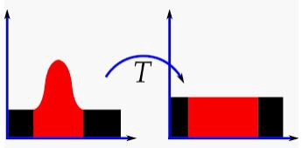

**Why Do You Use Histogram Equalization?**

Histogram Equalization can be used when you have images that look washed out because they do not have sufficient contrast. In such photographs, the light and dark areas blend together creating a flatter image that lacks highlights and shadows. So, we use histogram equalization to overcome this problem.

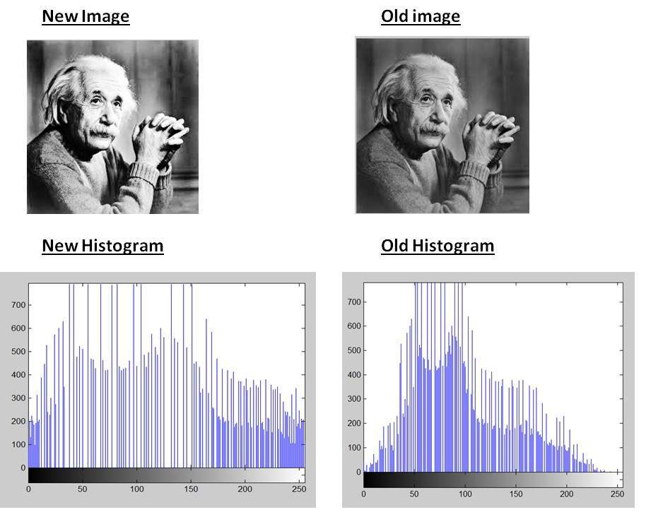

**CalcHist Function:**

We used the cv2.calcHist function to build our histograms. The function is:

cv2.calcHist(images, channels, mask, histSize, ranges)

* **Images:** This is the image that we want to compute a histogram for.
* **Channels:** A list of indexes, where we specify the index of the channel we want to compute a histogram for. To compute a histogram of a grayscale image, the list would be [0]

To compute a histogram for all three red, green, and blue channels, the channels list would be [0, 1, 2]

* **Mask:** Well, here we can supply a mask. If a mask is provided, a histogram will be computed for *masked pixels only*. If we do not have a mask or do not want to apply one, we can just provide a value of None
* **histSize:** This is the number of bins we want to use when computing a histogram. Again, this is a list, one for each channel we are computing a histogram for. The bin sizes do not all have to be the same. Here is an example of 32 bins for each channel: [32, 32, 32]
* **Ranges:**  The range of possible pixel values. Normally, this is *[0, 256]* (that is *not* a typo — the ending range of the cv2.calcHistfunction is non-inclusive so you’ll want to provide a value of 256 rather than 255).

**Code explanation:**

* For Object detection:

First, we import numpy and cv2, nothing fancy there. Next, we cay cap = cv2.VideoCapture(0). This will return video from the first webcam on your computer. If you are watching the tutorial videos, you will see I am using 1, since my first webcam is recording me, and the second webcam is used for the actual tutorial feed.

* Importing libraries:

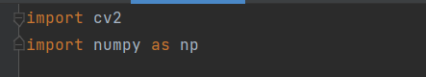

* Set the threshold values for object detection and nms boxes to set the final boxes:



* capturing the image using cv2 and setting the camera window size width and height:



* Importing the coco classes txt file and reading all 80 objects in it and storing them in a list:

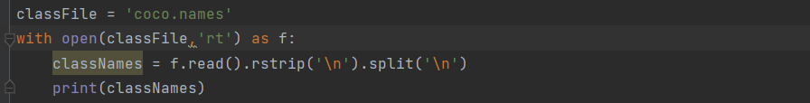

* Importing the requires files into the model:



* Defining the model architecture and converting into rgb format and normalizing the image and set the net size:

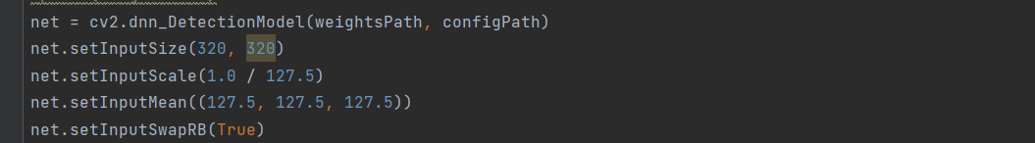

* .Importing the time librarty to calculate number of fps and running while loop for many time to calture all frames and return output continuously:

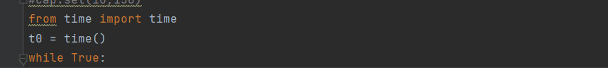

* Storing image and sending classids and and parameters into the model:

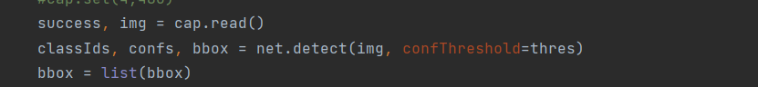

* .Predicting the bounding boxes and the confidence score of prediction and storing them in a list:
* Predicting the bounding boxes and setting nms threshold to model:



* .Running for loop to draw the confidence score and classids of bounding box on the ioutput and display it to the user:

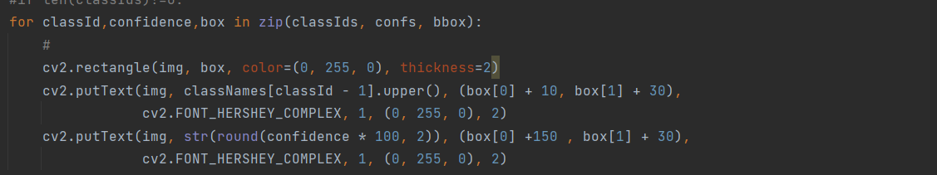

* .Displaying the output to the user and releasing all the empty space used:

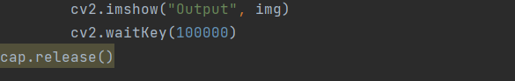

For face detection:

* Importing the required libraries
* Loading the required files of pretrained model:



* capturing the image using cv2 :



* Read the frames and uploading the frames to the model to predict faces:
* 
* Predict the faces and predict the eyes in faces and mark them:

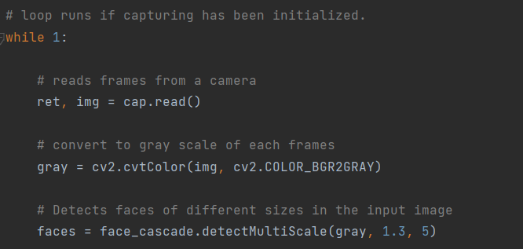

* Predict the faces and predict the eyes in faces and mark them by drawing rectangular bounding box:

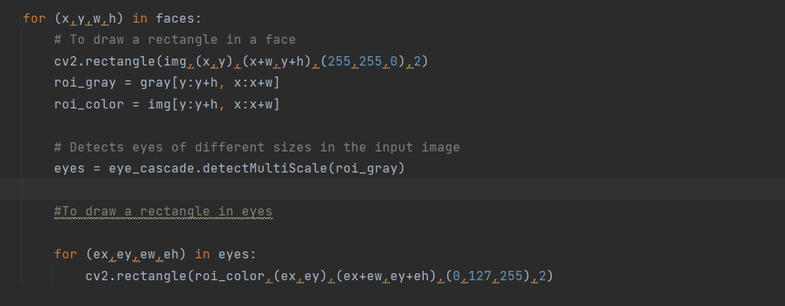

* Displaying the output for some until wait key is pressed:

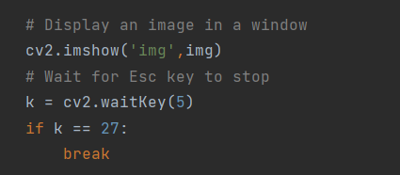

* To close the window and release the memory used:

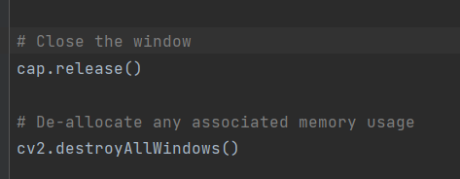

For Attendance system using face recognition:

1)For collecting dataset :

* Importing the required libraries

import cv2

import os

* Setting height and width of the capturing video

cam.set(3, 1080)

cam.set(4, 720)

* Loading the required files of pretrained model:

face_detector = cv2.CascadeClassifier('D:\ECE 2nd year sem1\AIML Project\Attendance\haarcascade_frontalface_default.xml')

* Collecting an unique id for each student:

face_id = input('\nEnter user id ==>  ')

print("\n [INFO] Initializing face capture. Look the camera and wait ...")

* Taking a face in a video and returning rectangular box around it and also storing it in the dataset:

while(True):

    ret, img = cam.read()

    #img = cv2.flip(img, -1) # flip video image vertically

    gray = cv2.cvtColor(img, cv2.COLOR_BGR2GRAY)

    faces = face_detector.detectMultiScale(gray, 1.3, 5)

    for (x,y,w,h) in faces:

        cv2.rectangle(img, (x,y), (x+w,y+h), (255,0,0), 2)

        count += 1

        # Save the captured image into the datasets folder

        cv2.imwrite("D:\ECE 2nd year sem1\AIML Project\Attendance\dataset/User." + str(face_id) + '.' +

                    str(count) + ".jpg", gray[y:y+h,x:x+w])

        cv2.imshow('image', img)

    k = cv2.waitKey(1000) & 0xff # Press 'ESC' for exiting video

    # print(count)

    if k == 27:

        break

    elif count >= 200: # Take 30 face sample and stop video

         break

# Do a bit of cleanup

print("\n [INFO] Exiting Program and cleanup stuff")

cam.release()

cv2.destroyAllWindows()

2)For training of faces :

* Importing the required libraries

import cv2

import numpy as np

from PIL import Image

import os

* Loading the required files of pretrained model:

path = "D:\ECE 2nd year sem1\AIML Project\Attendance\dataset"

recognizer = cv2.face.LBPHFaceRecognizer_create()

detector = cv2.CascadeClassifier("D:\ECE 2nd year sem1\AIML Project\Attendance\haarcascade_frontalface_default.xml");

* Detecting faces and returning the faces with their respective id’s

def getImagesAndLabels(path):

imagePaths = [os.path.join(path,f) for f in os.listdir(path)]

faceSamples=[]

ids = []

for imagePath in imagePaths:

img = Image.open(imagePath).convert('L') # grayscale

img_numpy = np.array(img,'uint8')

id = int(os.path.split(imagePath)[-1].split(".")[1])

faces = detector.detectMultiScale(img_numpy)

for (x,y,w,h) in faces:

faceSamples.append(img_numpy[y:y+h,x:x+w])

ids.append(id)

return faceSamples,ids

* Training the faces and saving into a file

print ("\n [INFO] Training faces. It will take a few seconds. Wait ...")

faces,ids = getImagesAndLabels(path)

recognizer.train(faces, np.array(ids))

recognizer.save('D:\ECE 2nd year sem1\AIML Project\Attendance\Trainner.yml')

print("\n [INFO] {0} faces trained. Exiting Program".format(len(np.unique(ids))))

3)For collecting attendance :

* Importing the required libraries

import cv2

import numpy as np

import os

import time

from datetime import datetime

* Loading the required files of pretrained model:

recognizer = cv2.face.LBPHFaceRecognizer_create()

cascadePath = "D:\ECE 2nd year sem1\AIML Project\Attendance\haarcascade_frontalface_default.xml"

recognizer.read('D:\ECE 2nd year sem1\AIML Project\Attendance\Trainner.yml')

* Setting height and width of the capturing video

id = 0

# names related to ids: example ==> Marcelo: id=1,  etc

names = ['None', 'Srimanth', 'Praveen','Shrikar']

# Initialize and start realtime video capture

cam = cv2.VideoCapture(0)

cam.set(3, 640) # set video widht

cam.set(4, 480) # set video height

# Define min window size to be recognized as a face

minW = 0.1*cam.get(3)

minH = 0.1*cam.get(4)

* Storing attendance in an excel sheet

l=[]

def atten(x):

    roll = {'Praveen' : '21ECB0B31', 'Srimanth' : '21ECB0B33','Shrikar' : '21ECB0B21', 'unknown' : '0'}

    file = open('D:\ECE 2nd year sem1\AIML Project\Attendance\Attendance.csv', 'a')

    y = x.strip()

    now = datetime.now()

    current_time = now.strftime("%H:%M:%S")

    if y not in l:

        file.write('"{0}", "{1}", "{2}"'.format(roll[y], y,current_time))

        file.write('\n')

    l.append(y)

* Calculating fps

while True:

    num_frames=120

#Start time

    start = time.time()

#Grab a few frames

    for i in range (0, num_frames) :

        ret, frame = cam.read()

#End time

    end = time.time()

# Time elapsed

    seconds = end - start

    print ("Time taken : {0} seconds".format(seconds))

# Calculate frames per second

    fps  = num_frames / seconds

    print("Estimated frames per second : {0}".format(fps))

* Identifying student’s name and returning rectangular box around face with accuracy

    ret, img =cam.read()

    gray = cv2.cvtColor(img,cv2.COLOR_BGR2GRAY)

    faces = faceCascade.detectMultiScale(

        gray,

        scaleFactor = 1.3,

        minNeighbors = 5,

        minSize = (int(minW), int(minH)),

       )

    for(x,y,w,h) in faces:

        cv2.rectangle(img, (x,y), (x+w,y+h), (0,255,0), 2)

        id, confidence = recognizer.predict(gray[y:y+h,x:x+w])

        if (confidence < 100):

                id = names[id]

                confidence = "  {0}%".format(round(confidence))

        else:

            id = "unknown"

            confidence = "  {0}%".format(round(confidence))

        cv2.putText(

                    img,

                    str(id),

                    (x+5,y-5),

                    font,

                    1,

                    (255,255,255),

                    2

                   )

        atten(id)

        cv2.putText(

                    img,

                    str(confidence),

                    (x+5,y+h-5),

                    font,

                    1,

                    (255,255,0),

                    1

                   )

    cv2.imshow('camera',img)

    k = cv2.waitKey(10) & 0xff # Press 'ESC' for exiting video

    if k == 27:

        break

# Do a bit of cleanup

print("\n [INFO] Exiting Program and cleanup stuff")

cam.release()

cv2.destroyAllWindows()

For plotting histogram and performing histogram equalization :

* Importing the required libraries

import numpy as np

import struct

import cv2

from matplotlib import pyplot as plt

* Taking hexadecimal bytes of an image taken by arduino 33 ble sense
* Converting hexadecimal intensities into an image
* raw_bytes = np.array(HEXADECIMAL_BYTES, dtype="i2")

image = np.zeros((len(raw_bytes),3), dtype=int)

# Loop through all of the pixels and form the image

for i in range(len(raw_bytes)):

    #Read 16-bit pixel

    pixel = struct.unpack('>h',raw_bytes[i])[0]

    #Convert RGB565 to RGB 24-bit

    r = ((pixel >> 11) & 0x1f) << 3;

    g = ((pixel >> 5) & 0x3f) << 2;

    b = ((pixel >> 0) & 0x1f) << 3;

    image[i] = [r,g,b]

image = np.reshape(image,(144, 176,3)) #QCIF resolution

#Show the image

plt.savefig('image.jpg')

plt.imshow(image)

plt.show()

* Plotting an histogram of the image

# reads an input image

img = cv2.imread('D:\ECE 2nd year sem1\AIML Project\Figure_1.png',0)

# find frequency of pixels in range 0-255

histr = cv2.calcHist([img],[0],None,[256],[0,256])

# show the plotting graph of an image

plt.plot(histr)

plt.show()

* Performing histogram equalization on an image

img = cv2.imread('D:\ECE 2nd year sem1\AIML Project\Figure_2.png', 0)

equ = cv2.equalizeHist(img)

res = np.hstack((img, equ))

# show image input vs output

cv2.imshow('image', res)

cv2.waitKey(0)

cv2.destroyAllWindows()

**OUTPUTS AND RESULTS:**

**Live video capturing from Arduino:**

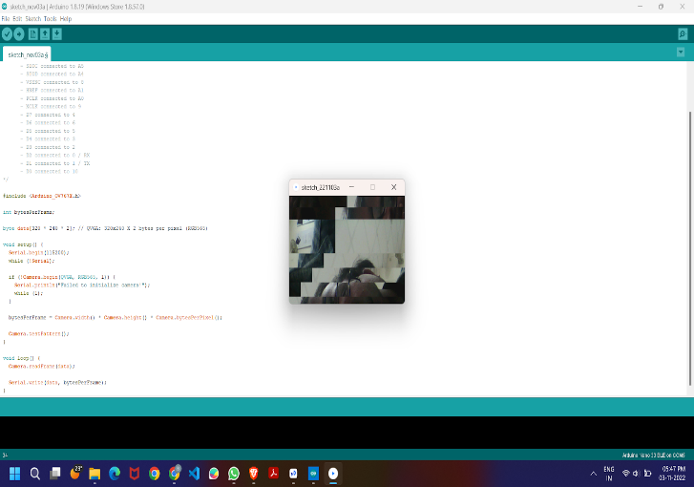

**Object detection in jetson nano**

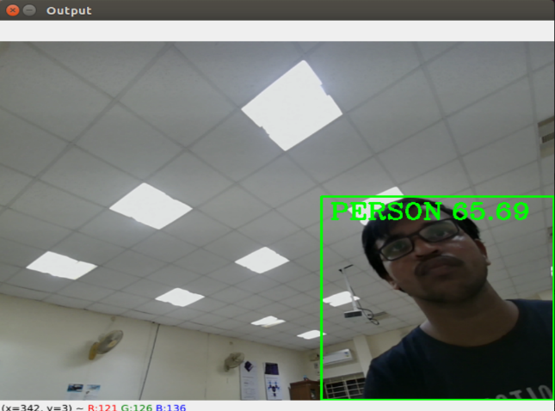

**Face and eye detection in jetson nano**

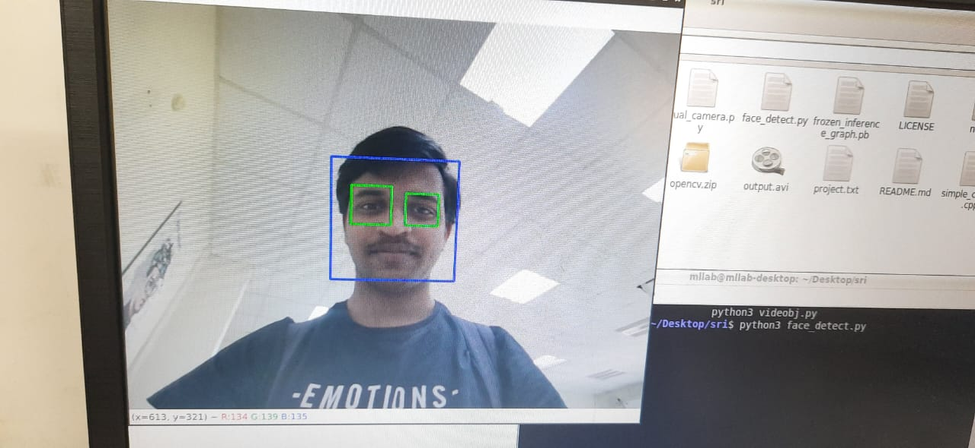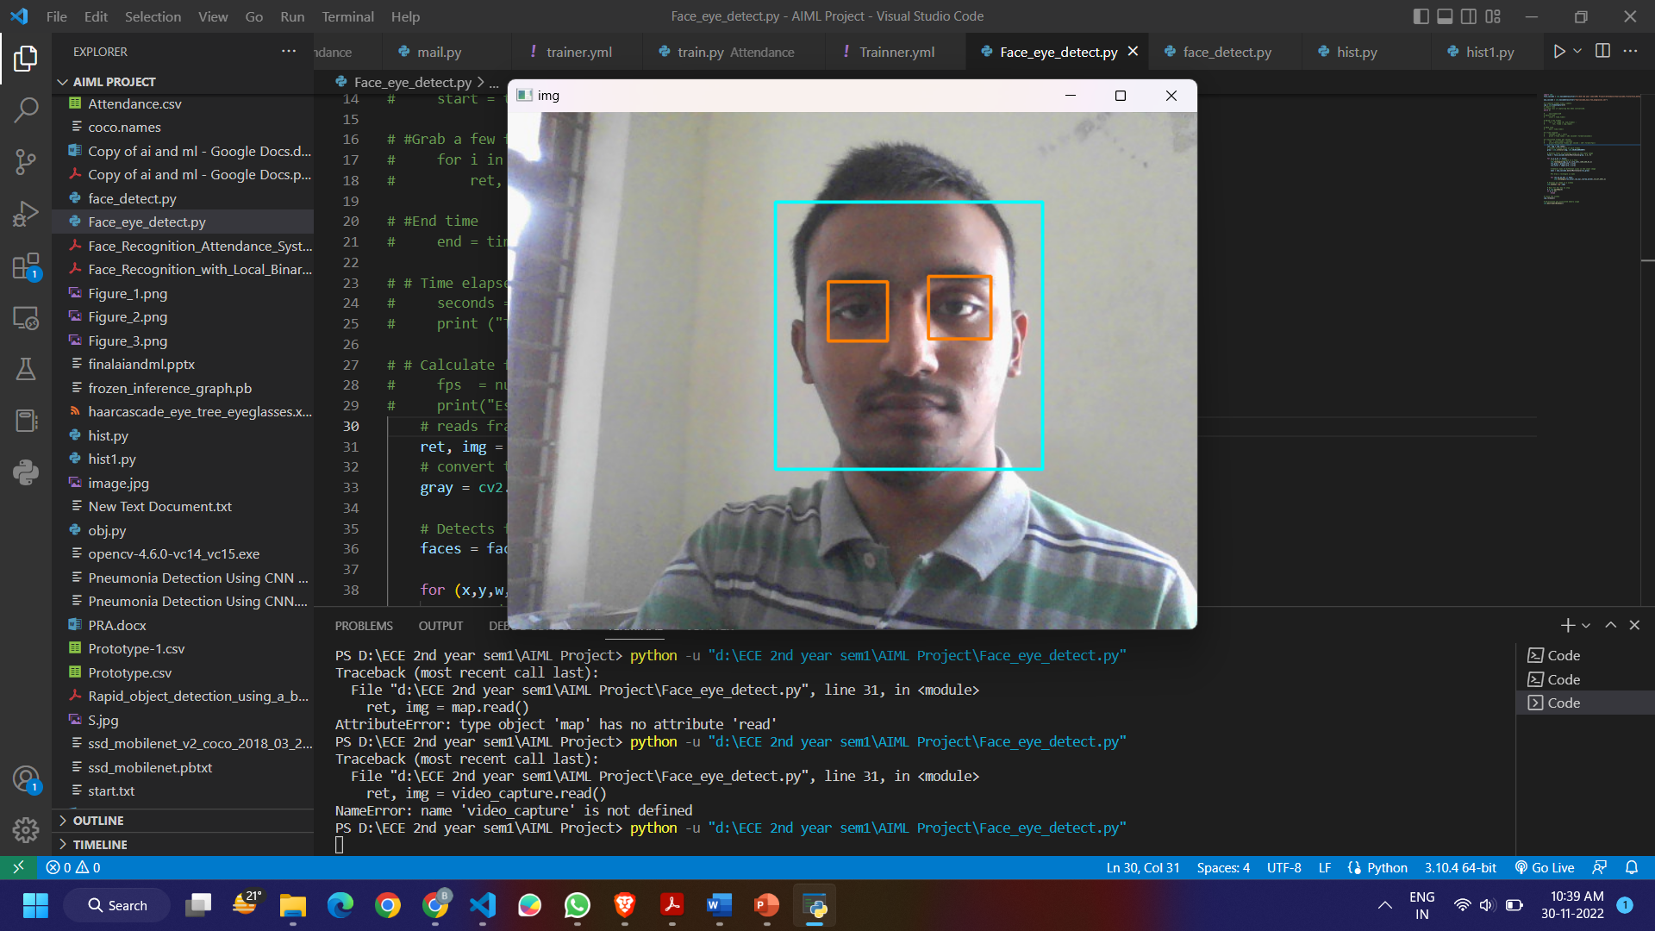

**Attendance using face recognition**

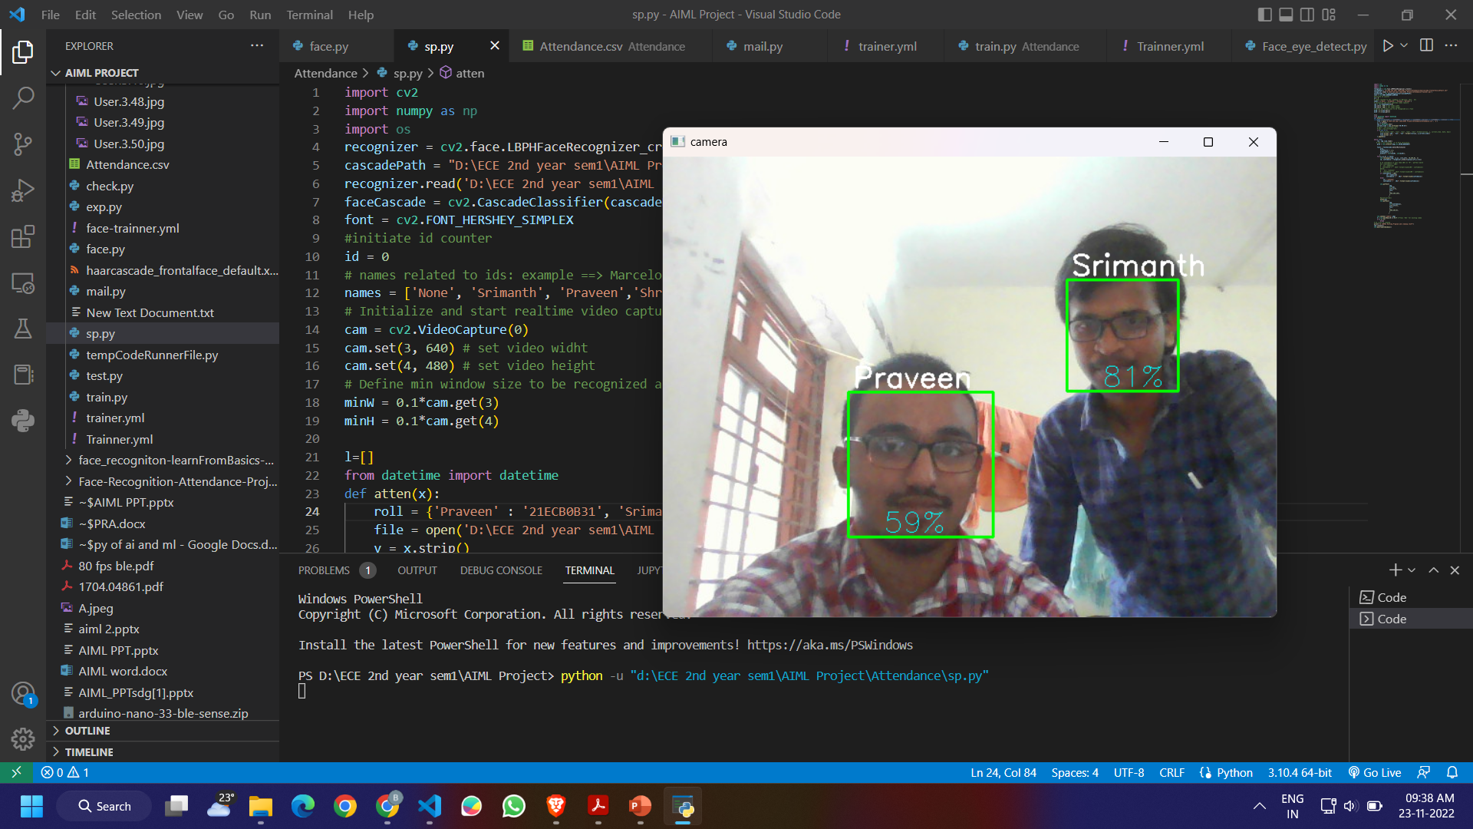

**Histogram of an image taken from Arduino 33 ble sense**

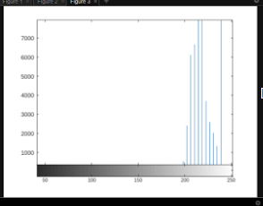

**Histogram equalization of an image taken from Arduino ble**

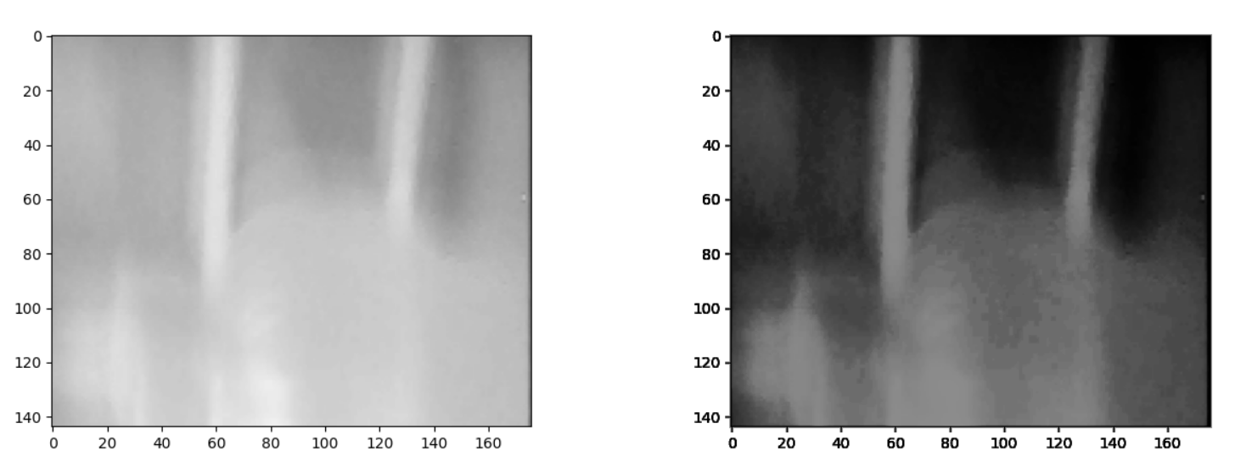

**CONCLUSION:**

We have implemented an attendance management system using face recognition for student’s attendance. Here, the LBP used to get features extracted. The facial images for detection and identification are taken by webcam and stored in database. LBPH recognizer is trained by the extracted features from database. This system helps to reduce time and effort, especially in the case of large number of students marked attendance. Time also will not get wasted in classes.

We also plotted histogram of an image and performed histogram equalization on an image which improves contrast of an image by taking an image from the Arduino 33 ble sense which is used for Tiny ML applications which is a booming technology in the current world.

**REFERENCES:**

* <https://ieeexplore.ieee.org/stamp/stamp.jsp?tp=&arnumber=8463886>
* <https://ieeexplore.ieee.org/stamp/stamp.jsp?tp=&arnumber=990517>
* <https://www.ijert.org/research/object-detection-using-yolo-and-mobilenet-ssd-a-comparative-study-IJERTV11IS060065.pdf>
* <https://www.researchgate.net/publication/316184205_MobileNets_Efficient_Convolutional_Neural_Networks_for_Mobile_Vision_Applications>
* <https://www.sciencedirect.com/science/article/pii/S0144860921000753>
* [**https://www.ijcrt.org/papers/IJCRT2005173.pdf**](https://www.ijcrt.org/papers/IJCRT2005173.pdf)

**FUTURE SCOPE**

* The future work is to improve the recognition rate of algorithms when there are unintentional changes in a person like tonsuring head, using scarf, beard. The system developed only recognizes face upto 30 degrees angle variations which has to be improved further. Gait recognition can be fused with face recognition systems in order to achieve better performance of the system.
* Our future work include to create an app for automatic attendance and implement it in our college and attendance will be captured and sent to corresponding professor .
* We also want to do image processing using Arduino ble 33 sense.
* We would like to do object detection and image classification on tiny ml devices like arduino nano ble33 sense and try to improve the accuracy  and implement these on various algorithms and check.